Noise in images:
Image noise is random variation of brightness or color information in the images captured. It is degradation in image signal caused by external sources.Images containing multiplicative noise have the characteristic that the brighter the area the noisier it. But mostly it is additive. We can model a noisy image as
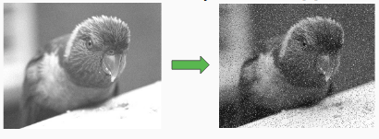

Sources of Image noise:
- While image being sent electronically from one place to another.
- Sensor heat while clicking an image.
- With varying ISO Factor which varies with the capacity of camera to absorb light.

1. Gaussian Noise:
Gaussian Noise is a statistical noise having a probability density function equal to normal distribution, also known as Gaussian Distribution. Random Gaussian function is added to Image function to generate this noise. It is also called as electronic noise because it arises in amplifiers or detectors. Source: thermal vibration of atoms and discrete nature of radiation of warm objects.
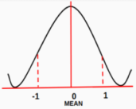
Fig.4 Plot of Probability Distribution Function
The side image is a bell shaped probability distribution function which have mean 0 and standard deviation(sigma) 1.
The magnitude of Gaussian Noise depends on the Standard Deviation(sigma). Noise Magnitude is directly proportional to the sigma value.
2.salt and Pepper Noise: Salt and Pepper noise is added to an image by addition of both random bright (with 255 pixel value) and random dark (with 0 pixel value) all over the image.This model is also known as data drop noise because statistically it drop the original data values [5]. Source: Malfunctioning of camera’s sensor cell.

3. Poisson Noise:
The appearance of this noise is seen due to the statistical nature of electromagnetic waves such as x-rays, visible lights and gamma rays. The x-ray and gamma ray sources emitted number of photons per unit time. These rays are injected in patient’s body from its source, in medical x rays and gamma rays imaging systems. These sources are having random fluctuation of photons. Result gathered image has spatial and temporal randomness. This noise is also called as quantum (photon) noise or shot noise.

